USERS AND ROLE

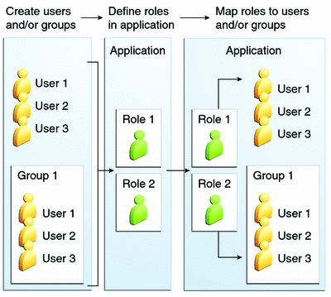

# List of the users and their roles

1. Role 0 – end user:
   1. Who ?
      1. Accessible to every network user with id
      2. Includes all the sailors
   2. What?
      1. Can overview their pc details (if pc a is linked with their id )
      2. Can use all the web applications end user features
      3. Can apply and track of the complaints
2. Role – 1 – dept. head / it in charge
   1. who
      1. Ship officers
      2. Dept. heads
      3. It in charge
   2. What?
      1. All the features of the role -0
      2. Full dept. items details
      3. Putting requirement for AMC staff for any issues
3. Role – 2 – AMC staffs
   1. Who?
      1. AMC staffs
   2. What?
      1. All features of the role-1
      2. Complaints assigned to them
      3. Mark the complaint closed or in progress or waiting or not possible with remarks
      4. Report for BR and upload BR certificates
4. Role – 3 – AMC managers
   1. Who?
      1. IT staffs
      2. AMC manager civilian
   2. What?
      1. All features of the role-1
      2. Can assign complaint to AMC staff
      3. Create list of tasks to be completed daily or for weekly
      4. Can able to create accounts for new user-role-0
      5. (additional): can reject /accept complaint request with remarks
5. Role-4- SOIT:
   1. Who?
      1. IT officer
   2. What?
      1. All features of role-2
      2. Can reject /accept the complaint and offer the BR certificate
6. Role-5- web site manager
   1. Can update any details in the code
7. Role-6- developer account
   1. Change all the codes for the website

Role -3

Role -0

Role -2

Role -1